Task-1 List 3 key differences between Ethernet cables and fiber optic cables, and give one real-world example where each type would be used (for example, home WiFi router, data center, college campus backbone).
Here are three key differences between Ethernet cables and fiber optic cables, along with a real-world example for each:

3 Key Differences
- Transmission Medium & Signal Type

  - Ethernet Cable: Uses copper wires to transmit data using electrical signals (voltage pulses).

  - Fiber Optic Cable: Uses thin strands of glass or plastic fiber to transmit data using pulses of light.

- Distance and Bandwidth Capabilities

  - Ethernet Cable: Generally limited to a maximum run of 100 meters (about 328 feet) per segment without signal boosters, and while modern copper (like Cat6a) supports up to 10 Gbps, speeds drop or suffer over long distances.

  - Fiber Optic Cable: Capable of transmitting massive amounts of data over extremely long distances (from kilometers to across oceans) with virtually no signal degradation.

- Susceptibility to Interference

  - Ethernet Cable: Vulnerable to Electromagnetic Interference (EMI) and Radio Frequency Interference (RFI) from power lines, heavy machinery, or fluorescent lights.

  - Fiber Optic Cable: Completely immune to electromagnetic interference because light signals are unaffected by electrical or magnetic fields.

Real-World Examples
- Ethernet Cable Example: Connecting a desktop gaming PC or a smart TV directly to a home Wi-Fi router or network switch for a stable, lag-free wired connection.

- Fiber Optic Cable Example: Serving as a college campus backbone to connect the network infrastructure of buildings spread across a large university campus, or linking server racks within a massive cloud data center.

Task-2 Draw and label a diagram showing the internal wiring of a straight-through Ethernet cable (use T568B wiring standard), indicating the color of each wire and its pin number.

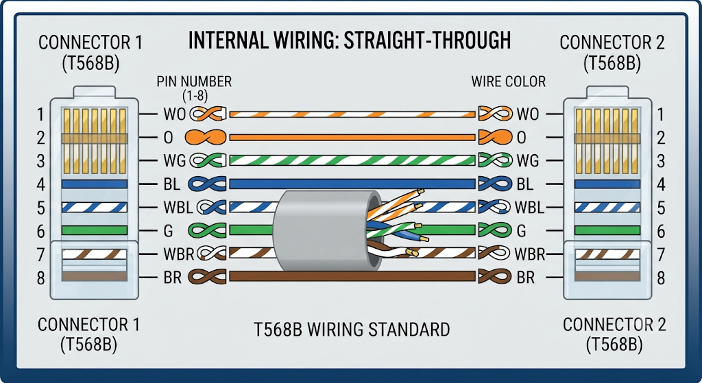

Task-3 Watch a YouTube video demonstrating how to use an RJ45 crimper, then write a step-by-step guide (in your own words) on how to attach an RJ45 connector to a CAT6 cable.
Here is a step-by-step guide on how to attach an RJ45 connector to a CAT6 cable, based on standard termination techniques:

Tools and Materials Needed
- CAT6 Ethernet cable

- RJ45 connectors (regular or pass-through)

- Protective rubber strain-relief boot (optional, but recommended)

- RJ45 crimping tool

- Wire strippers or cable snips

Step-by-Step Termination Guide
- Slide on the Strain-Relief Boot (Optional):

  - If you are using a protective rubber boot, slide it onto the cable first. Remember: once the RJ45 connector is crimped on, you won't be able to slip the boot over it!

- Strip the Outer Jacket:

  - Use your crimper's stripping blade or a utility knife to score the outer PVC jacket of the CAT6 cable about 1.5 to 2 inches from the end. Gently peel away and cut off the jacket to expose the internal twisted pairs and the central plastic spline (cross-web).

- Remove the Spline and Untwist the Wires:

  - Cut away the central plastic separator/spline down to the base of the jacket.

  - Untwist the four pairs of wires so you can work with individual conductors.

- Arrange Wires into the T568B Standard Order:

  - Straighten and flatten out the individual wires, organizing them strictly from left to right according to the T568B wiring color standard:

    - White/Orange

    - Orange

    - White/Green

    - Blue

    - White/Blue

    - Green

    - White/Brown

    - Brown

- Trim the Wires Evenly:

  - Hold the aligned wires tightly between your fingers. Use your wire snips to cut them straight across, leaving about half an inch (approx. 12–14 mm) of exposed wire sticking out past the jacket. This ensures the outer jacket can slide slightly inside the base of the connector for physical support.

- Insert Wires into the RJ45 Connector:

  - Carefully push the sorted wires into the RJ45 connector, keeping them flat and making sure each wire goes into its own individual channel.

  - Look closely at the front tip of the clear plastic connector to verify that all 8 copper wires reach all the way to the front. Also, make sure the outer cable jacket extends slightly inside the rear clamping area of the plug.

- Crimp the Connector:

  - Place the prepared RJ45 plug into the main crimping slot of your crimping tool.

  - Squeeze the handles firmly and completely until the ratchet mechanism releases. This forces the tiny metal pins (gold-plated teeth) down to pierce the wire insulation and locks the plastic strain relief tab onto the outer jacket.

- Inspect and Test:

  - Pull gently on the connector and cable to make sure it is secure. Inspect the pins visually to ensure all contacts are pushed down evenly. Finally, slide your rubber boot up over the back of the connector. (For reference, you can watch the demonstration here: Low Voltage Nation Tutorial).

Task-4 Imagine you are setting up a gaming café with 10 PCs for LAN gaming. Decide which cable type (Ethernet or fiber optics) and which tool (RJ45 crimper or fiber cleaver) you would use, and explain your choices in 3-4 sentences.Hint: Consider speed, distance, and budget for your answer.

For a gaming café with 10 PCs located close together, I would choose **Ethernet cables** (specifically Cat6 or Cat6a) paired with an **RJ45 crimper**. Since the distance between the PCs and the switch is well within the 100-meter limit and copper cables easily handle gigabit speeds for local multiplayer gaming, Ethernet is the most cost-effective and practical choice. Fiber optics and specialized fiber cleavers, while extremely fast, are unnecessary overkill and far too expensive for short runs inside a single local room.

